The California Division of Occupational Safety and Health (“Cal/OSHA”) has made revisions to its COVID-19 Prevention Emergency Temporary Standards (“ETS”). The new revisions have been incorporated below and are effective from May 6, 2022 – December 31, 2022.

Sample COVID-19 Prevention Plan for Re-opening a California Real Estate Office or AOR Office
(Updated May 9, 2022)

[Insert company name] (“Company”) has established this COVID-19 Prevention Plan to maintain the overall goals of preventing illness in the workplace and halting spread of COVID-19 in the community. The Company continues to keep apprised of changes to guidance from the State of California, in addition to standards for compliance under our county’s health orders, Cal/OSHA, the Centers for Disease Control and Prevention (CDC), and the California Department of Public Health (CDPH).

1. Contact Information for Local Health Department. The contact information for our local health department to communicate about any COVID-19 cases is listed here:
[Insert phone number, address, email address of local health department]. (You can find the contact information for your county here):
https://www.cdph.ca.gov/Pages/LocalHealthServicesAndOffices.aspx)

2. Office Location(s) and Designated Staff. Addresses for each of our office locations are listed here, with contact information for the person(s) in our Company who will implement the Company’s COVID-19 Prevention Plan:
[Insert physical office address, name, email address and phone number of designated person(s) who will implement the COVID-19 Prevention Plan]

3. Cal/OSHA ETS. The company is following the Cal/OSHA Covid-19 Prevention Emergency Temporary Standards (“ETS”). Accordingly, the Company will:
- Communicate to employees about the employer's COVID-19 prevention procedures.
- Identify, evaluate, and correct COVID-19 hazards in the workplace.
- Require and provide face coverings and respirators as specified in the ETS.
- Advise employees they can wear face coverings at work, regardless of their vaccination status, without fear of retaliation from the employer.
- Use engineering controls, administrative controls, and personal protective equipment under certain circumstances to prevent risk of COVID-19.
- Follow procedures to investigate and respond to COVID-19 cases in the workplace.
- Provide COVID-19 training to employees.
- Make testing available at no cost, on paid time, to: 1) Symptomatic employees (regardless of vaccination status and regardless of whether there is a known exposure); 2) All employees who have had a “close contact” with a COVID-19 case, except for recently recovered employees; 3) All employees (except for recently recovered employees and employees who were not at work during the relevant period) when there is an “outbreak” or a “major outbreak.” During an “outbreak,” all “close contacts” must either be tested or excluded from the workplace until the return-to-work requirements for COVID-19 cases are met. During a “major outbreak” all employees must either be tested or excluded until the return-to-work requirements are met; and 4) an employee, when the Company is following the CDPH Isolation and Quarantine Guidance for the purpose of keeping the employee working or to return them to work sooner.
- Follow exclusion rules for COVID-19 cases and exclude COVID-exposed employees from the workplace until they are no longer an infection risk.
- Follow criteria for employees who are returning to work after a COVID-19 case.
- Maintain records of COVID-19 cases and report serious illnesses to Cal/OSHA and to the local health department when required.

4. Identification, Evaluation, Correction of COVID-19 Risk Areas. The Company performed a COVID-19 risk assessment of each office to identify and evaluate any items to be corrected for COVID-19 prevention. The items we identified, and actions taken, are documented on Exhibit A with description(s) and date(s). The Company will continue to evaluate the office work areas on a regular basis for compliance with this Plan and the current guidelines and will correct deficiencies if identified.

5. Employee Training. Training for the Company’s employees on this COVID-19 Prevention Plan and other COVID-19 related topics was provided on [insert date]. Training included the topics and information described in Exhibit B.

6. Face Coverings. *[The May 6, 2022 Cal/OSHA ETS requires face coverings whenever CDPH requires their use. Currently, CDPH only requires face coverings in certain high-risk settings (e.g., healthcare settings). Check for any local requirements in your area. If your company will require face coverings for employees indoors, or while working in certain situations (e.g., large gatherings), add a description of your company’s policy regarding face coverings.]

The Company will provide face coverings or respirators (e.g., N95 mask) when requested by an employee. If an employee requests a face covering or respirator for voluntary use at work, the Company will provide the face covering or respirator at no cost to the employee, regardless of their vaccination status. For respirators, the Company will provide instruction to the employee on how to get a good “seal” or “fit.” The Company will ensure that the employee’s use of a respirator will not create a hazard (e.g., if the employee is engaged in strenuous physical activity like continuous heavy lifting) and the Company will provide respirator users with the information contained in California Code of Regulations Title 8, section 5144, Appendix D. See: https://www.dir.ca.gov/Title8/5144d.html If an employee prefers to select and purchase their own respirator, as an alternative, the Company may permit this and reimburse the employee.

7. Symptom Screening for COVID-19. *[Review and make appropriate revisions to the below section based on your company’s policy. You may make additions, e.g., whether employees will provide confirmation to the Company that they self-screened for COVID-19 symptoms, whether the Company chooses to provide temperature and/or symptom screenings for visitors entering the office, etc.] The Company will: 1) require employees to self-screen for COVID-19 symptoms at home, before coming to work; or 2) provide temperature and/or symptom screenings for all employees at the beginning of their shift (or before they enter the Company’s office). If the Company conducts symptom screening indoors, all persons are required to wear face coverings during the screening.

8. Cleaning. [Per the May 6, 2022 Cal/OSHA ETS, there are no cleaning and disinfecting requirements, and employers are not required to clean an office area or surfaces used by a positive COVID-19 case. Your company may choose whether to include a cleaning policy or requirements for your workplace. If your company has cleaning requirements (e.g., for shared break rooms or meeting rooms), you may choose to describe those requirements here.]

9. Physical Distancing. Per the May 6, 2022 Cal/OSHA ETS, there are no physical distancing requirements except during an “outbreak” or “major outbreak.” The Company will evaluate whether physical distancing is necessary to control transmission of COVID-19 during an “outbreak” (3 or more COVID-19 cases in a 14-day period). During a “major outbreak” (20 or more COVID-19 cases in a 30-day period) physical distancing will be used for all employees, except when the Company determines that maintaining 6-feet of distance is not feasible. If not feasible, then workers must be as far apart as feasible. The Company will continue to assess the safety of the workplace, and under certain circumstances the Company may determine that physical distancing is necessary.

10. COVID-Testing for Employees. The Company will offer COVID-19 testing at no cost to employees during paid time to: 1) Symptomatic employees (regardless of vaccination status and regardless of whether there is a known exposure); 2) All employees who have had a “close contact” with a COVID-19 case, except for recently recovered employees; 3) All employees (except for recently recovered employees and employees who were not at work during the relevant period) when there is an “outbreak” or a “major outbreak.” During an “outbreak,” all “close contacts” must either be tested or excluded from the workplace until the return-to-work requirements for COVID-19 cases are met. During a “major outbreak” all employees must either be tested or excluded until the return-to-work requirements are met; and 4) an employee, when the employer is following the CDPH Isolation and Quarantine Guidance for the purpose of keeping the employee working or to return them to work sooner.
*Per the May 6, 2022 Cal/OSHA ETS, employees can use a self-administered and self-read COVID-19 test. Observation by the employer or a telehealth proctor is no longer necessary. A date-and-time-stamped photograph verifying the test result is now sufficient.

11. Responding to a COVID-19 Case. The Company will take the following steps if it becomes aware of a COVID-19 illness at the workplace:

1) Determine when the person with COVID-19 was last in the office and, if possible, determine the dates of COVID-19 testing and onset of symptoms.
2) Determine which co-workers may have been exposed to COVID-19.
3) Notify workers (all employees present at the same worksite as the COVID-19 case), in writing, of any potential exposures within one business day (and notify any other employer who has potentially exposed employees, e.g., a temp agency).
4) Provide COVID-19 testing to potentially exposed employees at no cost and during paid time, with the limited exception of employees who recently recovered from COVID-19 and have not developed COVID-19 symptoms since returning to work.
5) Keep persons with COVID-19 and exposed employees from the workplace until they are no longer an infection risk.
6) Investigate and assess whether workplace conditions could have contributed to the COVID-19 risk, and determine whether corrections are needed to reduce future possible COVID-19 exposure.
12. Follow Current CDPH Isolation and Quarantine periods.
As of May 9, 2022, the CDPH Isolation and Quarantine periods are:
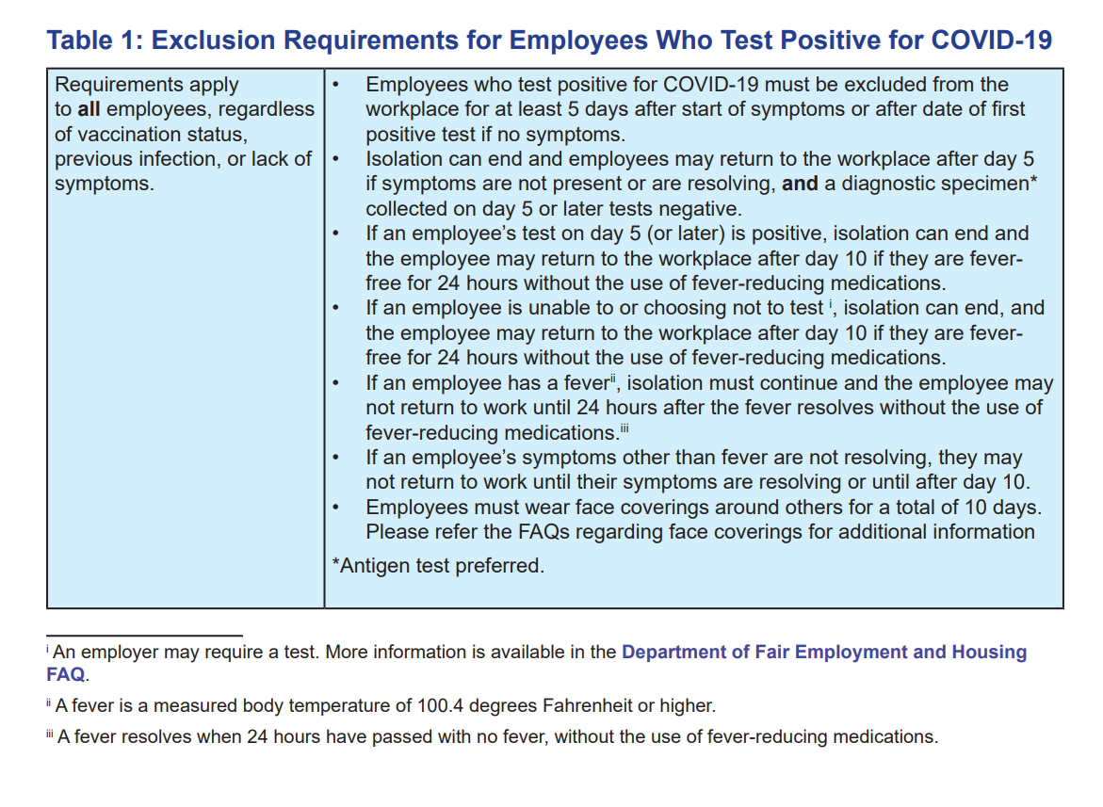

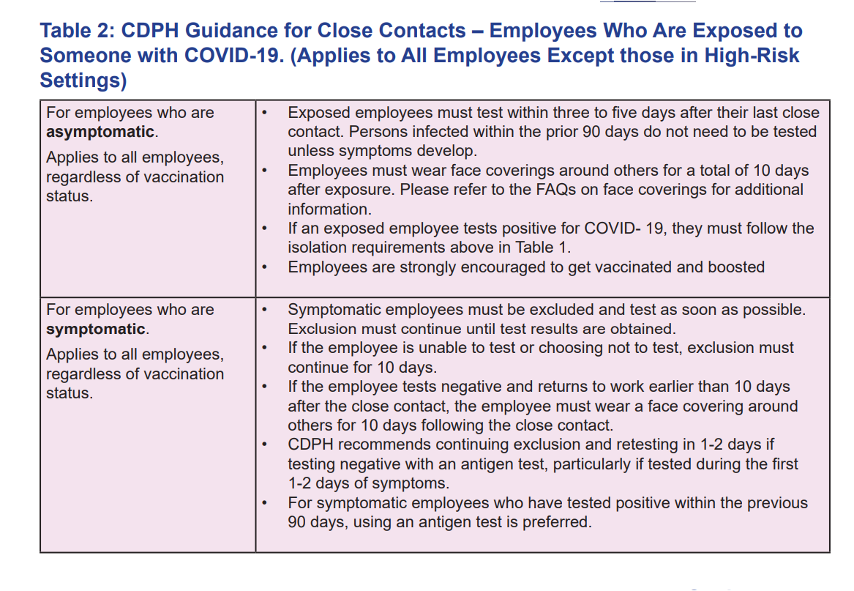
13. Exclusion pay for employees who cannot work or telework due to workplace exposure.
The Company will pay exclusion pay for eligible employees who cannot work or telework after workplace COVID-19 exposure, if the employee did not receive Disability Payments or Workers’ Compensation Temporary Disability Payments during the exclusion period.

14. [Include additional information here if there is Company-provided housing or Company-provided transportation to and from work. See Cal/OSHA requirements for Company-provided housing or Company-provided transportation here: https://www.dir.ca.gov/dosh/coronavirus/ETS.html]
Exhibit A: Risk Assessment-- Items Identified
and Actions Taken by Company

[Insert Office Location, Date of Action, Description] Example: 123 Main Street, El Segundo: On May 25, 2022, the Company added hand sanitizer stations, stocked face coverings and respirators, and checked the ventilation system.

Exhibit B: Employee Training on COVID-19 Prevention
(Per Cal/OSHA ETS 5.6.22)

Employee training on COVID-19 includes:
1) How employees should report COVID-symptoms, possible “close contacts,” and COVID-19 hazards to the employer, without fear of retaliation.
2) The company’s policies and procedures to protect employees from COVID-19 risks/hazards and how employees can participate in identifying and evaluating risks/hazards.
3) Best practices for preventing transmission of COVID-19, including information on respirators (e.g., COVID-19 is an infectious disease that can be spread through the air when an infectious person talks or vocalizes, sneezes, coughs, or exhales; COVID-19 may be transmitted when a person touches a contaminated object and then touches their eyes, nose, or mouth, although that is less common; and that an infectious person may show no symptoms; use of face coverings and respirators).
4) Employees can request a respirator from the employer (All employees may request a respirator for voluntary use, without fear of retaliation and at no cost to the employee). How to properly wear a respirator and perform a seal check, and the fact that facial hair interferes with the seal. Inform employees that respirators such as N95s are more effective at preventing COVID-19, an airborne disease.
5) ) Employees can request a face covering from the employer for voluntary use and at no cost to the employee. Information on the proper use of face coverings and the fact that face coverings are not respiratory protective equipment (Explain the conditions under which face coverings must be worn at work). Inform employees that they may wear face coverings at work, regardless of vaccination status, without fear of retaliation by the employer.
6) The importance of frequent hand washing for at least 20 seconds and use of hand sanitizer when handwashing facilities are not available.
7) The symptoms of COVID-19 and the importance of not coming to work and getting tested if an employee has symptoms.
8) How employees can access COVID-19 testing and vaccination, such as through the local health department or at a community testing center. Inform employees that vaccination is effective at preventing COVID-19, protecting against both transmission and serious illness or death.
9) Advise employees that the employer will notify employees of potential exposure to COVID-19.
10) How employees with elevated risk factors for COVID-19 (information may be found on the CDC website) can request accommodations from the employer.
11) Information about COVID-19 related benefits that may be available to employees, such as paid sick leave and workers’ compensation available from the employer and/or from federal, state, or local government. Information on COVID-19 benefits is posted on the Department of Industrial Relations’ Coronavirus Resources webpage.

